Temple Solel's 16th Annual Night at the Baysox

Tuesday, June 11 at 6:35 PM
Subhead. Subhead. Subhead. Subhead.

VS.
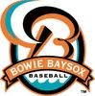
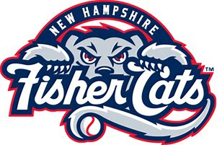
For the 17th year, Temple Solel is going to see our Bowie Baysox and raise money for the Temple. We hope those of you with kids of all ages will join us and enjoy a great summer evening at Prince George’s Stadium to watch future Orioles when the Baysox take on the New Hampshire on Tuesday, June 11 at 635 pm.

Lower reserved seats cost $14 for adults and $10 for children (3 -12). These are the green seats with arm rests near (but not next to) the field. You get $1 off the advanced adult ticket price.

There is an opportunity for one of us to step on the field and make the first pitch, by auctioning it off to the highest bidder. Submit your bid by June 7 to Bob Michelson or email it to robert.michelson@verizon.net. The minimum bid is $36. We will publish a list of the sponsors and the winning bid for the first pitch in September’s Temple Topics.

To join us, fill in the form on the bottom of this flyer and mail it to the Temple along with your check or pay on line at www.templesolelmd.org. Tickets will be mailed to you if the order form is received by June 4. Orders received after that date will be available at Will Call.

Name: _______________________________________ Phone no. (____)________

Total # of Tickets_____
Lower Reserved - Adult @ $14 each ____ Children (3 -12) @ $10 ___ Total $_____

Sponsorships
I’d like to be a Sponsor of the First Pitch:

Home Run $25 Triple $18 Double $9 Single $5

Total Enclosed $____
Total Charged $ ____

Name as it appears on credit card:

___________________________________________
Type of Card: Visa: __ MasterCard: __ Discover: __

Credit Card Number: _________________________________________________________

Exp. Date: ___ Billing Zip Code: _____ Security/CV Code: ___

Signature: ___________________________________________________

